Leo Ames
Class of 1963
Coach Bob Derryberry

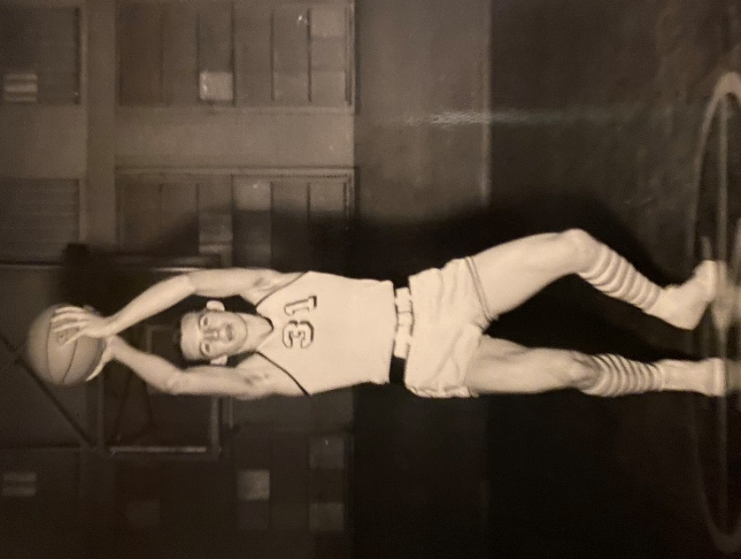
Whether you speak to a “seasoned” or a “younger” community member when discussing Millsap High School Basketball, Leo Ames’ name is always mentioned as one of the all-time greats in basketball history for MHS.
Leo played during a time when the mindset of athletics began to change under the direction of Coach Bob Derryberry. As Coach Derryberry, now deceased, stepped onto the court with his whistle in hand, the players knew they had a higher standard to achieve under his guidance. Before Coach Derryberry arrived at MHS, the guys wore blue jeans to practice. He quickly changed their mindset into an athlete’s perspective and each of the players embraced his philosophy and reaped the benefits.
Leo embraced the new way of thinking and began to realize that winners practice after everybody else goes home. Leo was known for his great jumping ability. He attributed that to extra practice of jumping at home while wearing combat boots. The speed that Leo displayed had opponents stopping in their tracks as he had taken the ball and scored before the opponent had time to realize what was happening.
Under the leadership of Leo Ames, his team excelled to new heights for Millsap athletics as they reached the State 1A Basketball Tournament. He led the team in scoring, averaging 17 points per game. As the 1963 Sr. headed with his team to the state tournament, they traveled by vehicle to play their first game against a tough West Sabine team. This team had researched Millsap basketball and double-teamed Leo, holding him to 11 points. In game two, Millsap faced a salty Stratford team and won 3rd place defeating Stratford 46-43 led by Leo who scored 21 points.
Ames ended his Senior season with several accolades including the All-District Team, All-State Team and becoming a member of the North All-Stars. In addition to his achievements on the hardwood, Leo also excelled in track and field as a regional representative.
Leo moved to Kansas where he worked in carpentry, farming, as well as general labor.
Although Leo passed away in 2015, the legacy of his exceptional basketball career remains alive today as we honor him as one of Millsap’s all-time greats.

